;l

Foundations of Programming

Assignment No. : 4
- PROBLEM STATEMENT: Write a C Program to calculate the salary of an employee given his basic pay (taken as input from the user). Calculate gross salary of employee. Let HRA be 10 % of basic pay and TA be 5% of basic pay. Let employees pay professional tax as 2% of total salary. Calculate net salary payable after deductions.

OBJECTIVE:

- To understand the importance of flowchart for any programming model.
- To learn simple flowchart symbols and arrows to define relationships.
- To understand and develop visual representations of flow of data.

THEORY:
- Define Algorithm.
- What are the different characteristics of an algorithm.
ALGORITHM:
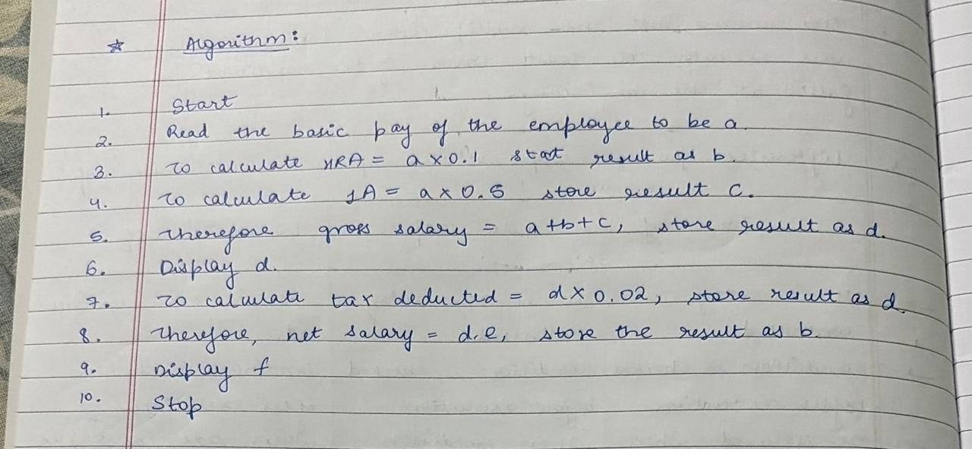
FLOWCHART:
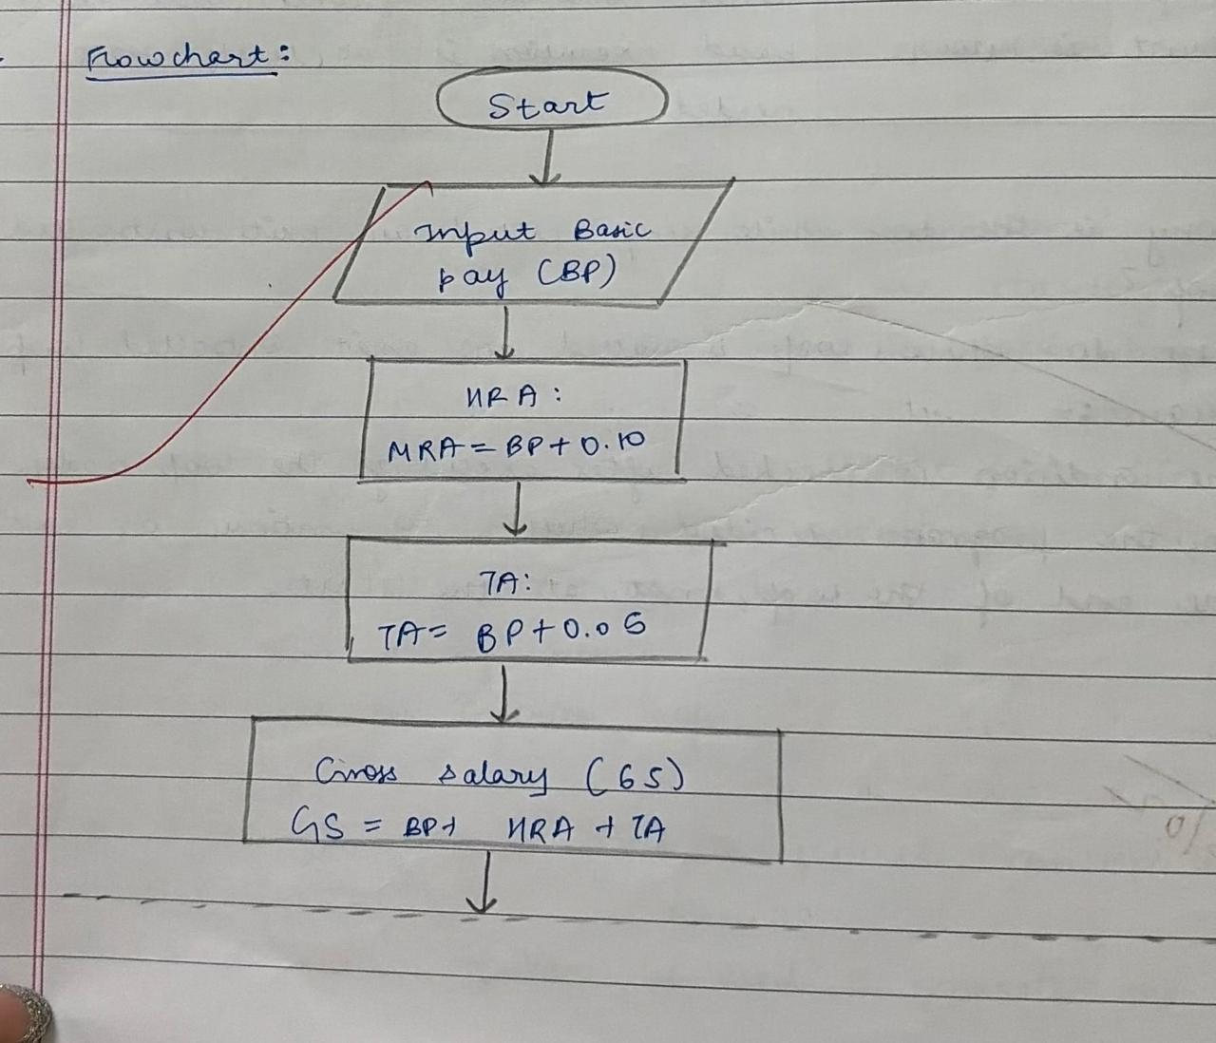
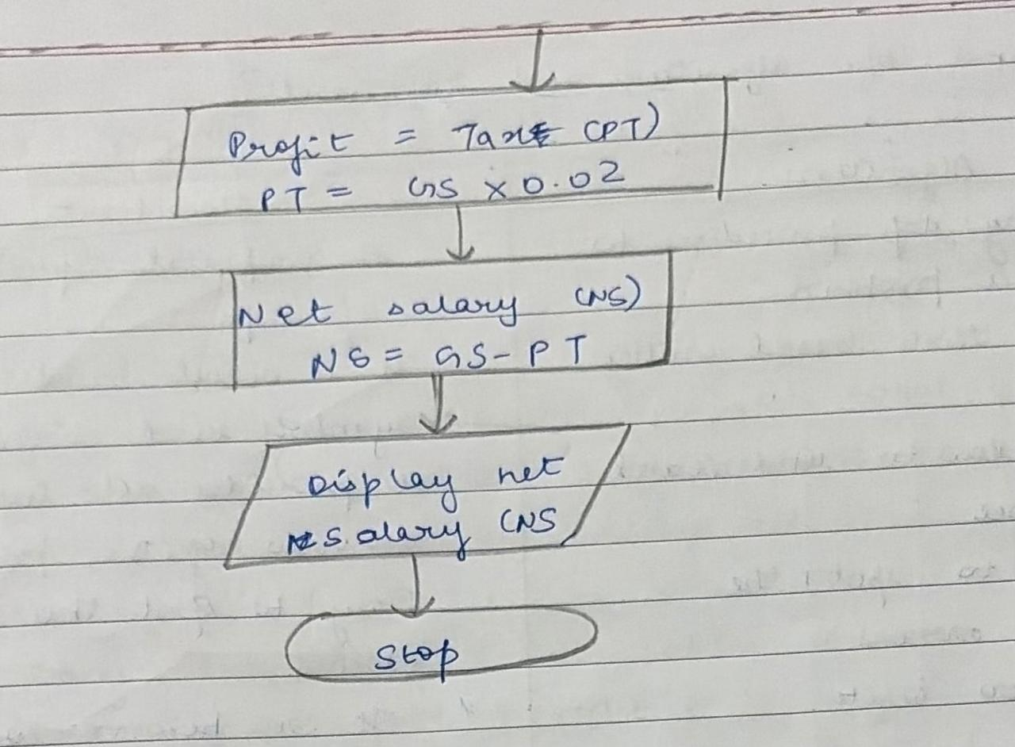
CODE:
#include <stdio.h>

int main() {
float basic, hra, ta, gross, tax, net;
printf("Enter Basic Salary: ");
scanf("%f", &basic);
hra = 0.10 * basic; // 10% HRA
ta = 0.05 * basic; // 5% TA

gross = basic + hra + ta; // Gross Salary

tax = 0.02 * gross; // 2% Professional Tax

net = gross - tax; // Net Salary
printf("\nHRA = %.2f", hra);
printf("\nTA = %.2f", ta);
printf("\nGross Salary = %.2f", gross);
printf("\nProfessional Tax = %.2f", tax);
printf("\nNet Salary = %.2f", net);

return 0;
}

PLATFORM: Linux

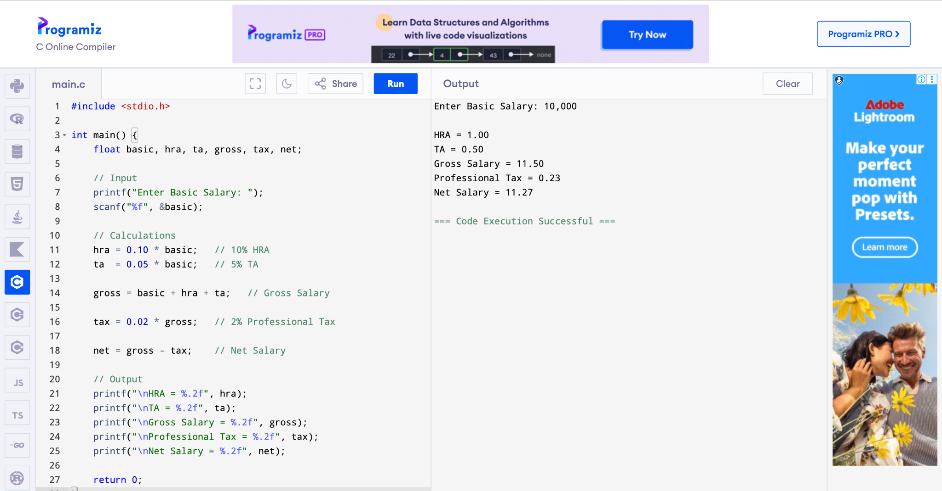
CONCLUSION: Thus, we have learned to write algorithms and to draw its representation in terms of flowchart.

FAQs:
- Describe various symbols and their use in flowchart.
- Difference between Algorithm and Flowchart.

